

PROJECT ENGINEERING

PROJECT PROPOSAL

Application Window Formatter

Tony Leonard

G00372842

Bachelor of Software and Electronic Engineering Galway-Mayo Institute of Technology

2021/2022

**Project Description:** The project I hope to create is an application window formatter. I decided to research this idea for my project as I am always moving around the applications on my desktop while I am coding and researching for my modules. I plan to create my project using Python with Win32gui libraries that will allow me to set the position and dimensions of any desktop application window and bring it to the foreground of the desktop. I also plan to implement a mouse tracker that tracks how long the user spends on each of the application windows which is also using the Win32gui libraries. I will use the data from the mouse tracker to form bar charts and pie charts to display how long the user is spending on each application which will be shown on the web application. For the cloud services I hope to acquire the student deal with Amazon Web services, and I plan to use MongoDB for my database.

**Challenges and complexities:** The biggest challenge I believe I will face is setting up the database as I have no prior knowledge with how to do it. This is also true for setting up the cloud to store the database as I have done very little cloud computing in the past.

**Architecture Diagram:**

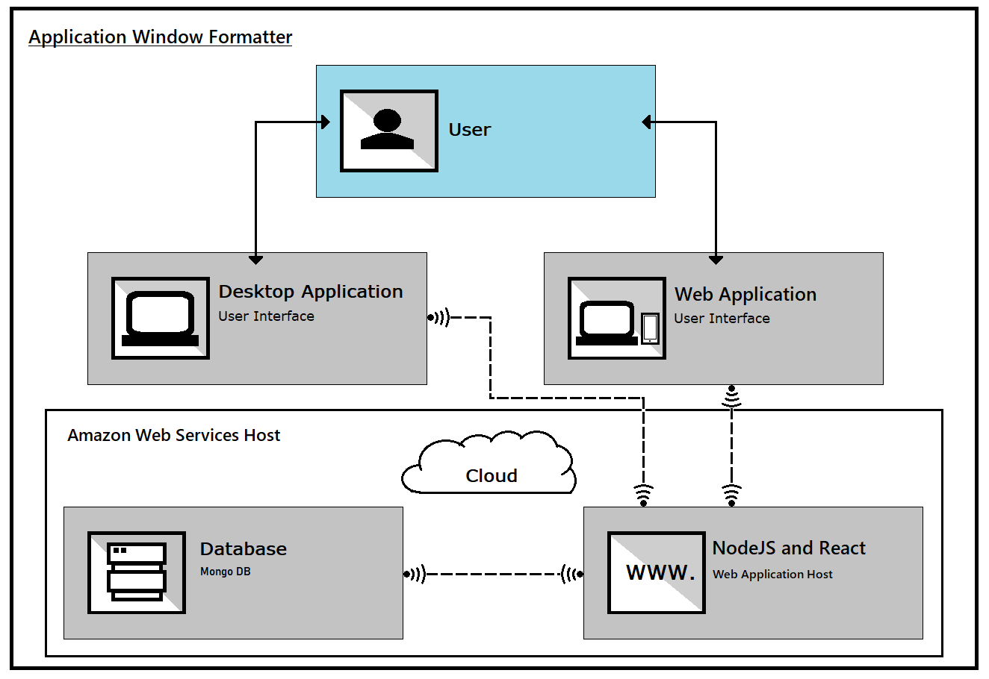

**Timeline for Tasks and Deliverables:**

**Coding Languages:** Python, JavaScript (React), HTML, CSS.

**Hardware Components**: There are no hardware components involved with this project.